**DIESEL GENERATOR SET**

# Model: DY-31YC.Rate Power: 31kVA/ 50Hz/ 3 phases

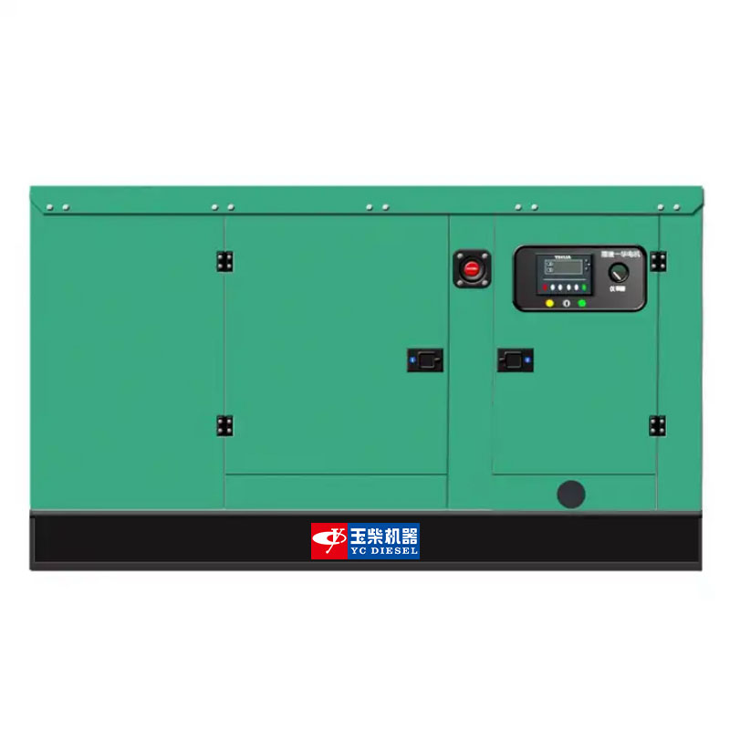

**Applications:**

Home, Buildings, Hospitals, Train station, Bank, Telecom, Mining, Military, Outdoor projects, etc.

• LCD display shows system status setup information

# Generator Data

|  |  |
| --- | --- |
| Prime Power (kVA) | 31 |
| Standby Power (kVA) | 34 |
| Rated Frequency (Hz) | 50 |
| Running Noise db(A)/7m (Silent type) | 65±3 |
| Voltage (V) | 230/380 |
| Curent (A) | 45 |
| No.Phase | 3 |
| Silent Type-Dimension (LxWxH) (mm) | 1900x900x900 |
| Silent Type-Weight (kg) | 700 |
| Fuel Tank Capacity (L) | 120 |
| Power factor | 0.8 |

Engine Model

|  |  |  |  |  |  |  |  |
| --- | --- | --- | --- | --- | --- | --- | --- |
| Engine speed | Application | Generator set power | | Engine power | | | |
| Gross power | | Net power | |
| r/min |  | kVA | kW | kVA | kW | kVA | kW |
| 1500 | Prime | 30 | 24 | 38 | 30 | 35 | 28 |
| Standby | 33 | 26 | 41 | 33 | 39 | 31 |

# YCV2.5T45-G20

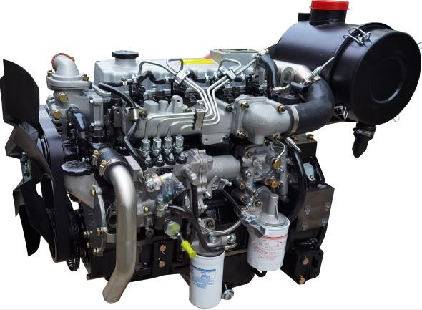

(

Image shown may not reflect actual engine

)

## Prime Power

It corresponds to the prime rated power (PRP) of GB/T 2820 and ISO 8528, and refers to the maximum power accessible at the variable load for an unlimited running hours per year, with the maintenance intervals and procedures being carried out as prescribed by Yuchai, and the allowed average output power within 24 h shall not be higher than 70% of the prime power.

## Standby Power

It corresponds to the emergency standby power (ESP) of GB/T 2820 and ISO 8528, and refers to the maximum power accessible at a certain variable load series in the event of a utility power outage or under test conditions for an limited running hours up to 200 h per year, with the maintenance intervals and procedures being carried out as prescribed by Yuchai. The allowed average output power within 24 h shall not be higher than 70% of the standby power.

**Main technical parameters Centre of gravity (dry engine, with the center of the**

### rear end face of the flywheel shell as the origin)

Cylinder quantity ....................................................................... 4

From the rear end face of the flywheel………………............…../

Type .................................................................... Vertical, in-line

Height relative to the center of the crankshaft…………............./

Aspiration ............................................................. Turbocharged

Centerline deviation relative to the crankshaft center gravity

Combustion system ........................................... . Direct injection

……………………………………………………………….......…../

Valve quantity per cylinder ........................................................ 2

## Moments of rotation inertia

Compression ratio ............................................................ 17.5:1

Engine ....................................................................................... /

Bore ............................................................................... . 89 mm

Flywheel ......................................................................0.31 kg·m2

Stroke .......................................................................... . 100 mm

## Performance rating

Displacement .................................................................... . 2.5 L

Speed droop ....................................................................... ≤3 %

Rotation………Counterclockwise (viewed from the flywheel end)

Steady state speed band ................................................. ≤0.5 %

Firing order (viewed from front end)…..............................1-3-4-2

## Test conditions

Minimum no-load speed ................................. . (700～750) r/min

Ambient temperature ......................................................... .25 ℃

Speed-regulation grade ........................................ . ISO 8528 G3

Atmospheric pressure .................................................... . 100 kPa

Dry weight (without radiator) .......................................... .220 kg

Relative humidity .................................................................. 30 %

Wet weight (without radiator) ........................................ . 250 kg

Max. operating intake resistance .................................... .≤5 kPa

### Overall dimensions

Exhaust backpressure limit ............................................ ≤10 kPa

Length (from front end of radiator to rear end of air filter)

Fuel temperature (fuel inlet pump)…………………....…..38±2 ℃

…………………………………………………………….....1105 mm

### Flywheel and flywheel housing size

Width . ……………………………………………………….634 mm

Flywheel………………………………………………………SAE 7.5

Height (with radiator and mounting support). .......... …....796 mm

Flywheel housing……………………………………………SAE 4#

### Cooling system

Total coolant capacity………………………………………13.5 L

Engine coolant capacity………………………………….....2.5 L

Radiator coolant capacity…………………………………....10 L

Pipeline coolant capacity…………………………………….... 1L

Engine max. outlet coolant temperature…………………...98℃ Thermostat operation temperature:

Initial open………………………………………………...(70±2)℃ full open…………………………………………………......＜80℃

Max. coolant temperature rise:

-Standby power……………………………………………....8.5℃

-Prime power……………………………………………………8℃

### Radiator

Cooling area……………………………………………..…13.1m2

Dry weight…………………………………………………....20 kg

Core material………………………………………….Aluminium

Width of core……………………………………………..508 mm

Height of core…………………………………………….480 mm

Min. pressure of pressure cap.................................(75±5)kPa

Coolant resistance limit………………………………..≤15 kPa **Coolant pump**

Rotation speed…………………………………………..4000 r/min

Drive mode.............................................................Pulley driven

Coolant flow………………………………………………..60 L/min **Fan**

Diameter…………………………………………………....430 mm

Drive ratio……………………………………………………1.37:1

Material………………………………………....................Plastics

Number of blades………………………………………………7

Type………………………………………………………....Blowing

Air flow…………………………………………………....60m³/min

#### Fuel system

Injection system...................Mechanical pump+electronic governor **Injector**

Type…………………………………......Mechanical+mulriple jets

Injector opening pressure ............... …………………….24 MPa **Fuel pump**

Drive mode ............................................................ Gear driven

Fuel delivery pump flow @1,500 rpm ........................... 1 L/min

Max. fuel inlet temperature limit ........................................ 70℃

Allowed fuel inlet pressure of front end of fuel delivery pump

(absolute pressure) ............................................ .(35~100) kPa

Maximum fuel return pressure of fuel pump .................. 20 kPa **Fuel filter**

Rated flow .................................................................. 1.2 L/min

Max. original resistance ................................................. . 7 kPa Filtering efficiency:

For particles of ≤4 μm.............................................. ≥98.5 %

For particles of （6~14） μm ...................................... ≥99 %

For particles of ≥14 μm ............................................ ≥99.9 %

#### Fuel consumption

**Note:** Thedensity of diesel is 0.835 kg/L

|  |  |  |
| --- | --- | --- |
| **Load condition** | **1500 r/min** | |
| **g/(kW·h)** | **L/h** |
| Standby | 230 | 9.1 |
| Prime | 224 | 8.0 |
| 75% prime | 232 | 6.3 |
| 50% prime | 237 | 4.3 |

#### Lubricating system

Total oil capacity(dry engine) ............................................ 6.5 L

Total oil capacity(oil change) ................................................ 6 L

Oil sump capacity - low level/high level ........................... 3.5/6 L

Max. oil temperature (in oil sump) ………………………...125 ℃

Operating oil temperature(in oil sump)…………….. (90~110) ℃

Oil pressure(idle speed) ........................................... .≥100 kPa

Oil pressure(rated speed) ................................... (200~600) kPa

Oil-fuel consumption ratio ............................................. .＜0.2 % **Oil filter**

The filtering efficiency at the rated flow of 16 L/min and the assembly initial resistance ≤25 kPa:

For 15μm≤particles＜20μm................................................＞75%

For 20μm≤particles＜30μm................................................＞95%

For 30μm≤particles＜40μm................................................＞99%

For particles≥40μm...................................................＞99.9999%

#### Inclination

Transverse inclination(volume of engine oil sump:

6L).....................................................................................±10°

Longitudinal inclination (volume of engine oil sump:

6L) ……………………………………………………...........±10°

**Intake system**

### Air filter

Max. intake resistance:

-Clean air filter ............................................................ . 2.5 kPa

-Dirty air filter ................................................................. . 5 kPa

-Air filter type........................Dry-type, filter cartridge of paper

### Air intake flow

Prime power operation………………………………..2.04 m³/min

Standby power operation……………………………..2.11 m³/min **Exhaust system**

Max. exhaust backpressure ............................................. 10 kPa

Inner diameter of exhaust port pipe…………………....Φ48 mm

Exhaust temperature………………………………………＜600℃

### Exhaust flow

Prime power operation………………………………....4.4 m³/min Standby power operation……………………………..4.56 m³/min

#### Electric system

Type………………………………………………..Negative ground

**Charger**

Voltage ......................................................................... 28V/14V

Output current ........................................................... 26.7A/65A

**Starter**

Type ....................................................................Electric start, 1

Voltage ......................................................................... 24V/12V

Power .................................................................... 4.5kW/3.7kW

Number of teeth of flywheel ................................................ .117

Number of teeth of starter ....................................................... 11

#### Cold start

|  |  |  |  |  |  |
| --- | --- | --- | --- | --- | --- |
| 24 V | | | | | |
| Battery specification×quantity:12V/200Ah×2 | | | | | |
| Starting temperature | ℃ | -15 | -20 | -25 | -30 |
| Starting speed | r/min | 215 | 185 | 153 | 138 |
| Starting current | A | 246 | 305 | 342 | 372 |
| Starting voltage | V | 20.16 | 18.96 | 18.48 | 17.9 |
| Starting time | s | 2.6 | 2.9 | 4.8 | 5.6 |
| Preheating time | s | 0 | 40 | 50 | 60 |

(test data, for reference)

### Auxiliary intake heater (recommended)

Type .......................................................................................... /

Specification ............................................................................. ./

### Water preheater (recommended)

Recommended specification. ............................... .1.5 kW/220 V

Engine preheater water outlet interface ...................... . NTP1/4

Engine preheater water inlet interface ...................... . M12×1.5

### Oil heater (recommended)

Recommended specification. ................................ .150 W/220 V

Interface (oil sump, 1) ................................................ . M14×1.5

**Noise**

### Noise data (30 kW @ 1500 r/min)

|  |  |  |  |  |  |  |  |  |  |  |  |  |  |  |  |  |  |  |  |  |  |  |
| --- | --- | --- | --- | --- | --- | --- | --- | --- | --- | --- | --- | --- | --- | --- | --- | --- | --- | --- | --- | --- | --- | --- |
| |  |  | | --- | --- | | **Position** | **Noise, dB(A)** | | 1 | 80.6 | | 2 | 86.6 | | 3 | 85.4 | | 4 | 90.3 | | 5 | 86.5 | | 6 | 87.5 | | 7 | 79.8 | | 8 | 80.9 | | 9 | 85.2 | |  | Engine    Flywheel end |
|  |
|  |

### Noise spectrum (30 kW @ 1500 r/min)

|  |  |  |  |  |  |  |  |  |  |  |  |  |  |  |  |  |  |  |  |  |  |
| --- | --- | --- | --- | --- | --- | --- | --- | --- | --- | --- | --- | --- | --- | --- | --- | --- | --- | --- | --- | --- | --- |
| |  |  | | --- | --- | | **Frequency, Hz** | **Noise, dB(A)** | | 63 | 43.2 | | 125 | 55 | | 250 | 70.5 | | 500 | 72.6 | | 1k | 75.7 | | 2k | 76.5 | | 4k | 75 | | 8k | 64.6 | | 16k | 52.9 | |  |

#### Dimension

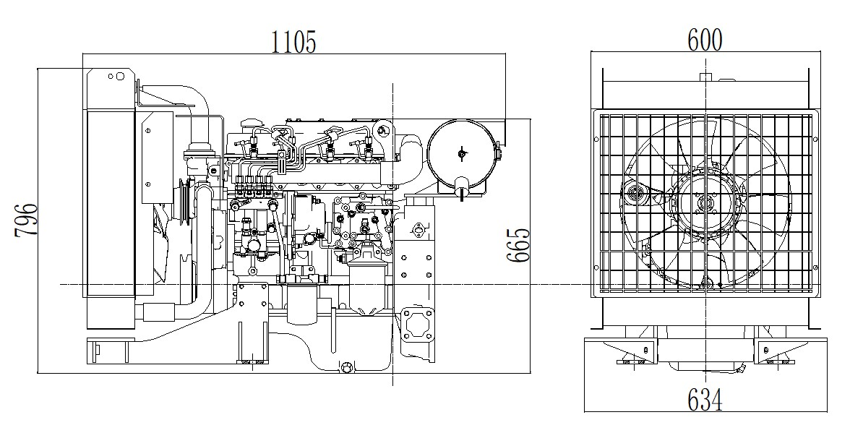

**THREE – PHASE SYNCHRONOUS GENERATOR 三相同步发电机技术参数表**



**DY-31GB**

**Datasheet For 4 Poles - 50Hz @ 1500rpm / 60Hz @ 1800rpm**

|  |  |
| --- | --- |
| **Ambient Temperature环境温度** | 40°C |
| **Temperature Rise 温升** | 125°C |
| **Insulation Class 绝缘等级** | Class H |
| **Power Factor功率因数** | 0.8 |
| **Excitation 励磁方式** | Brushless无刷 |
| **Winding Pitch 绕组节距** | Two Thirds (2/3) |
| **Pole极数** | 4 |
| **Voltage Regulation - in steady state condition 电压调节** | +/- 0.5% |
| **Duty工作方式** | S1 - Continuous |
| **AVR Model AVR型号** | ETC-A1 |

|  |  |
| --- | --- |
| **Short Circuit Current Capacity 短路电流容量** | >300% |
| **Waveform : TIF** | <50 |
| **Waveform : THF 波形畸变率** | <2% |
| **Total Harmonic Content 总谐波含量** | < 2% - At no load |
| **Method of Cooling 冷却方式** | IC01 |
| **Direction of Rotation 旋转方向** | Counter-clockwise顺时针 |
| **Maximum Over-speed 最高转速** | 2250 rpm |
| **Degree of Protection / Enclosure 防护等级** | IP23 |
| **Altitude 海拔** | ≤1000 m.a.s.l |
| **Radio interference 无线电干扰** | Class B Group 1 |

**Electrical and Mechanical Characteristic 电气和机械特性**

|  |  |  |  |
| --- | --- | --- | --- |
| **Frequency频率** | **Hz** | **50** | **60** |
| **Speed转速** | **rpm** | **1500** | **1800** |
| **Voltage ( series star ) 电压** | **V** | **400** | **480** |
| **Rated power at Class H (125º C) temperature rise额定功率在类**  **H(125ºC) 温升** | **kVA** | 31 | 34 |
| **kW** | 25 | 27.5 |
| **Efficiency at Class H (P.F.=0.8) 绝缘等级H (P.F.=0.8) 效率** | **4/4%** | 86 | 86.3 |
| **3/4%** | 87.3 | 87.7 |
| **2/4%** | 86.6 | 87 |
| **Efficiency at Class H (P.F.=1.0) 绝缘等级H (P.F.=1.0) 效率** | **4/4%** | 89.2 | 89.7 |
| **3/4%** | 90.6 | 91.2 |
| **2/4%** | 89.9 | 90.5 |

**H 绝缘等级 H**

|  |  |  |  |
| --- | --- | --- | --- |
| **Short-circuit ratio 短路比** | **Kcc** | 0.3680 | 0.3680 |
| **Direct axis synchronous reactance unsaturated 直轴同步电抗** | **Xd** | 2.7170 | 2.7170 |
| **Quadrature axis synchronous reactance unsaturated 交轴同步电抗** | **Xq** | 1.3960 | 1.3960 |
| **Direct axis transient reactance saturated 直轴瞬态电抗** | **X'd** | 0.1880 | 0.1880 |
| **Direct axis subtransient reactance saturated 直轴瞬变电抗** | **X"d** | 0.1670 | 0.1670 |
| **Quadrature axis subtransient reactance saturated 交轴起始瞬态电抗** | **X"q** | 0.2040 | 0.2040 |
| **Zero sequence reactance unsaturated 零序电抗不饱和** | **X0** | 0.0430 | 0.0430 |
| **Leakage reactance漏抗** | **X1** | 0.1070 | 0.1070 |
| **Negative sequence reactance saturated 负序电抗饱和** | **X2** | 0.1855 | 0.1855 |

|  |  |  |  |
| --- | --- | --- | --- |
| **Open circuit time constant (sec.) 开路时间常数** | **T'do** | 0.5140 | |
| **Short-circuit transient time constant (sec.) 短路瞬变时间常数（秒）** | **T'd** | 0.0310 | |
| **Subtransient time constant (sec.) 超瞬变时间常数（秒。）** | **T"d** | 0.0064 | |
| **Armature time constant (sec.)电枢时间常数** | **Tα** | 0.0123 | |
| **No load excitation current空载励磁电流** | **io(A)** | 0.5 | 0.5 |
| **Full load excitation current满载励磁电流** | **ic(A)** | 1.8 | 1.8 |
| **Full load excitation voltage 满载励磁电压** | **uc(V)** | 29 | 29 |
| **Stator Winding Resistance (20℃) 定子绕组电阻 (20℃)** | **ohm** | 0.2137(Star Serie)星串联 | |
| **Rotor Winding Resistance (20℃) 转子绕组电阻 (20℃)** | **ohm** | 0.9082 | |
| **Exciter Stator Resistance (20℃) 励磁机定子电阻 (20℃)** | **ohm** | 17.22 | |
| **Exciter Rotor Phase resistance 励磁机转子相电阻** | **ohm** | 0.04490Ω PER PHASE @20°C | |
| **Cooling air requirement 空气冷却要求** | **m3/sec** | 0.119 | 0.143 |

|  |  |  |
| --- | --- | --- |
| **Configuration 结构** | Single Bearing单轴承 | Double Bearing双轴承 |
| **Type of Construction 结构形式** | B2 - SAE | IM B34 |
| **Inertia (J) [kgm2] 惯性（J）[ kgm2）** | 0.29 | 0.284 |
| **Total Weight - kgs 总重量-公斤** | 178 | 175 |
| **Drive end bearing / Lubrication 驱动端轴承/润滑** | Not supply | 6306 C3-2Z / Prelubricated - sealed for life密封轴承 |
| **Non-drive end bearing / Lubrication非驱动端轴承/润滑** | 6306 C3-2Z / Prelubricated - sealed for life密封轴承 | |
| **Recovery time - sec. 恢复时间** | 0.5 | |
| **Stator winding 定子绕组** | DOUBLE LAYER CONCENTRIC同心式 | |
| **Number of Terminal 终端数量** | 12 | |
| **Rotor转子结构** | with damping cage带阻尼绕组 | |
| **Overload超载** | 110% rated load for 1 hour 110%额定负载1小时 | |

**STANDARD COMPLIANCE - IEC 60034-1; CEI 2-3; BS 4999-5000; VDE 0530; NF 51-100,111; OVE M-10, NEMA MG 1.22.**

# Control Panel System

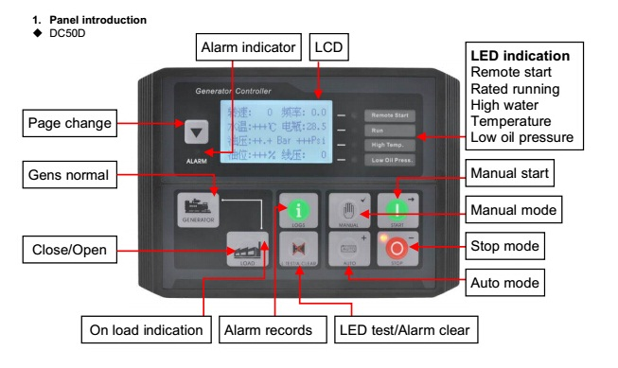

**Main Features:**

|  |  |  |
| --- | --- | --- |
| * Using microprocessor as a core, graphics LCD with big screen and backlight, key touch for operation * All parameters use digital modulation, with higher reliability and stability * Built-in speed/frequency detecting units can accurately judge the states such as crank success and over speed |  | * Security password-protected programming levels * Power supply range is wide, accommodating to different starting battery voltage environment * Built-in watch dog can never be dead halt, ensuring smooth program execution * Modular configuration design, inserted type connection terminals, flush type installation, compact structure, easy installation |
| **Precision measure and display of:** |  | **Protection:** |
|  Generator voltage |  |  Emergency stop |
|  Generator current |  |  High water temperature |
|  Generator frequency |  |  Low oil pressure |
|  Generator active power (kW) |  |  Over speed |
|  Generator inactive power (kW) |  |  Under speed |
|  Generator apparent power (kVA) |  |  Loss of speed signal |
|  Generator power factor |  |  Generator over frequency |
|  Generator starts count |  |  Generator under frequency |
|  Generator hour count |  |  Generator over voltage |

Data and Technical Specification are subject to change in order to update or improve the products, without prior notice